 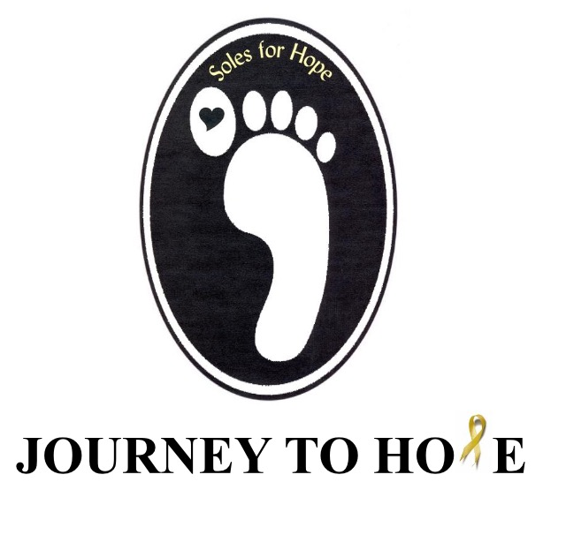



**safeTALK**

safeTALK, is a training that prepares anyone over the age of 15 to identify persons with thoughts of suicide and connect them to suicide first aid resources. Most people with thoughts of suicide invite help to stay safe. Alert helpers know how to use these opportunities to support that desire for safety. As a safeTALK-trained suicide alert helper, you will be better able to:

* move beyond common tendencies to miss, dismiss or avoid suicide;
* identify people who have thoughts of suicide;
* apply the *TALK* steps *(Tell, Ask, Listen* and *KeepSafe)* to connect a person with suicide thoughts to suicide first aid, intervention caregivers.

Powerful video clips illustrate both non-alert and alert responses. Discussion and practice help stimulate learning. Learn steps that contribute to saving lives

Date: Tues, Oct 1, 2019

Location: Crescent Park Event Centre

262 Athabasca St.E., Moose Jaw, Sk

Time: 1:00-4:00pm

Cost: FREE - **Journey to Hope** is sponsoring anyone that is within the

Five Hills Health Region.

* $50 for other participants

For more information or to register contact CMHA at 306-692-4240 or

e-mail: nemaa@cmhask.com

 



**Registration**

**Name:__________________________________________________________**

**Address: _______________________________________________________**

**Email: __________________________________________________________**

**Date of Training: ________________________________________________**

**Do You require Sponsorship: ____________________________________**

**Payment will be made by:**

**Visa**

**Mastercard**

**Cheque**

**Please Invoice**

**For more information or to register contact CMHA at 306-692-4240 or**

**e-mail: nemaa@cmhask.com**